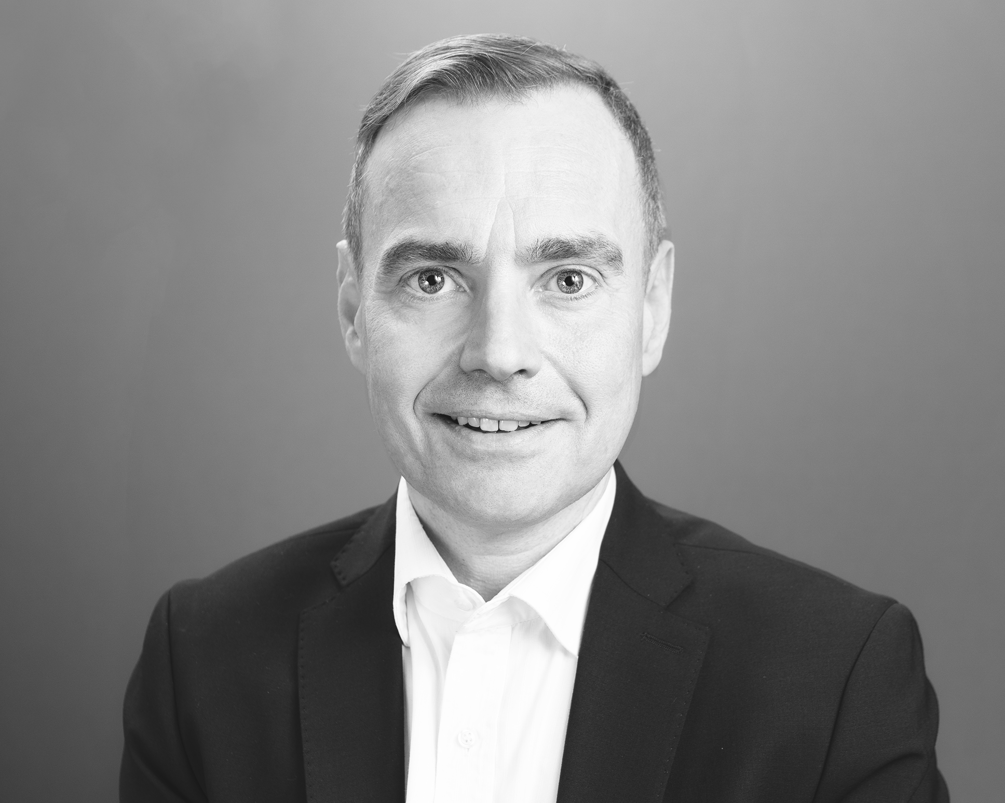
Mark Heines

Curriculum Vitae

Lyric tenor Mark Heines developed his wide-ranging repertoire under the guidance of the distinguished Hungarian soprano, Krisztina Laki and the English tenor Alastair Thompson, one of the founding members of the King's Singers.
Mark's highly acclaimed dramatic interpretations of Bach's Passion Oratorios have made him one of the most highly regarded Evangelists of his generation. The musicality, confidence, clarity and security of his performances have also won him acclaim in works by Haydn, Handel, Mendelssohn and Rossini as well as in Lied and song recitals.
On stage, Mark is a versatile and highly sought after tenor, equally at home in the Classical and Romantic repertoires and he has performed in works by Handel, Mozart, Rossini, Donizetti and Puccini. He also takes a keen interest in contemporary music and has participated in world premières of works by Samir Odeh-Tamimi, Sofia Gubaidulina and Wolfgang Rihm as well as performing in compositions by Hans Werner Henze, Tan Dun, Claude Vivier, Karlheinz Stockhausen, Arvo Pärt and Salvatore Sciarrino.
As a chorister he has worked frequently as a freelance member of three major German radio choirs: Rundfunkchor Berlin, MDR Leipzig and WDR Cologne and has worked with renowned conductors such as Sir Simon Rattle, Sir Roger Norrington, Zubin Mehta, Yannick Nézet-Séguin, Anders Eby, Stefan Parkman and Helmuth Rilling.

As of: May 2024

For additional information please visit:
https://www.markheines.de

Contact:
Mark Heines, 3 The Gardens, BR3 5PH, Beckenham, Kent, United Kingdom
Tel.: +44.(0)208.658.6469
Mobile: +44.(0)7541.774.739
post@markheines.de

