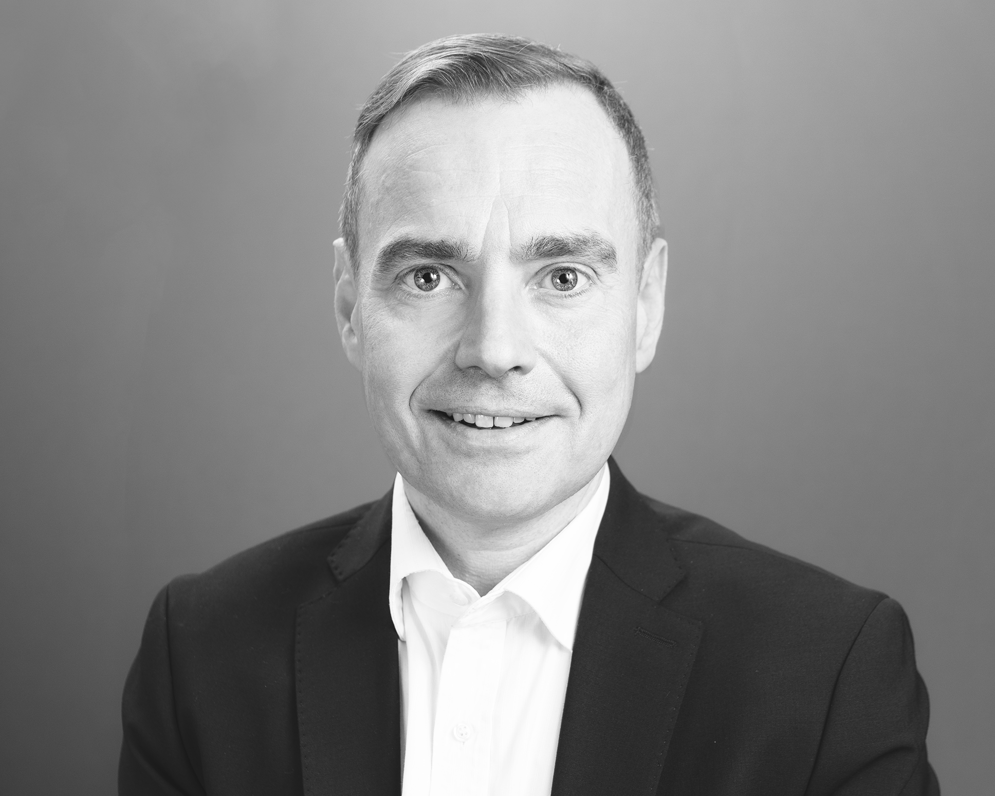
Mark Heines

Curriculum Vitae

London-based tenor Mark Heines specialises in the baroque and classical repertoire. He's known especially for his dramatic performances in Bach, Handel, Mozart, Mendelssohn and Rossini as well as his work in contemporary music and opera. He studied with Alastair Thompson, founding member of the King's Singers.

As of: May 2024

For additional information please visit:
https://www.markheines.de

Contact:
Mark Heines, 3 The Gardens, BR3 5PH, Beckenham, Kent, United Kingdom
Tel.: +44.(0)208.658.6469
Mobile: +44.(0)7541.774.739
post@markheines.de

